PROJECT DESIGN PHASE II

**Functional Requirements**

|  |  |
| --- | --- |
| Date | 15 September 2022 |
| Team ID | PNT2022TMID30411 |
| Project Name | Project Design Phase -2 Functional Requirements |
| Maximum Marks | 4 Marks |

**Sensors:**

**\*Purpose:**

**\*Capture Motion movement and relay the information to device B(Clip)**

**\*Parts:**

**\*Arduino Nano:**

**\*We need the device to be light and convenient for use.**

**\*PIR motion sensor (Passive Infared):**

**\*Detects the motions and send the signal to the RF transmitter.**

**\*RF Transmitter:**

**Receives the signal from the PIR Sensor and sends it to the clip device.**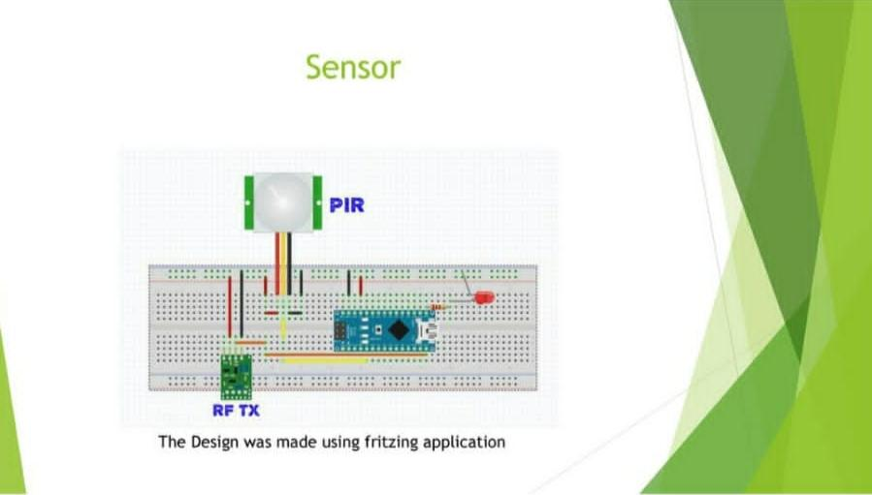

***\*Clip (Wearable Device)***

**\*PURPOSE:**

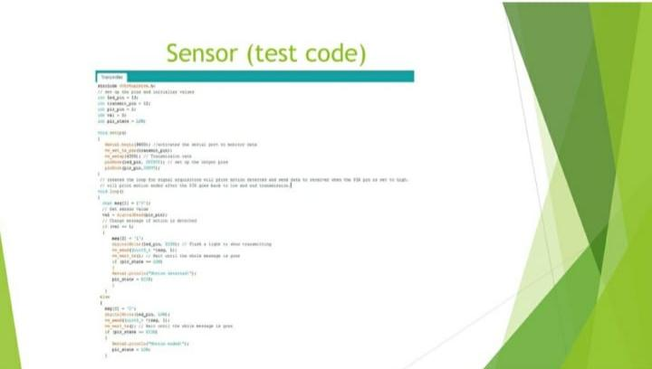**\*RECEIVE THE MOTION SIGNAL**

**\*READ INPUT FROM ACCELEROMETER**

**\*RELAYS SOUND TO DEVICE C (ROUTER)**

**\*ARDUINO UNO:**

**\* NEEDED TO USE THE ACCELEROMETER SHEILD**

**\*RF RECEIVER:**

**\*RECEIVE THE SIGNAL FROM THE MOTION SENSOR**

**\*ACCELEROMETER:**

**\*CAPTURE SHACKING MOVEMENTS.**

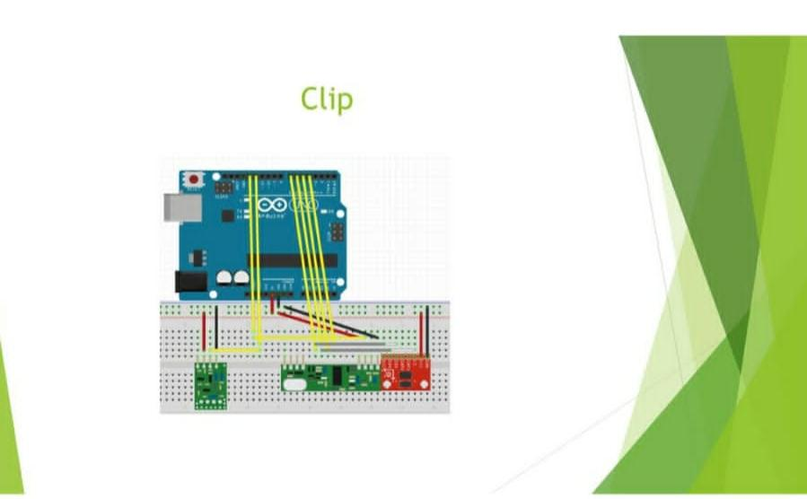

**\*ROUTER:**

**\*PURPOSE:**

**\* RELAY INFORMATION BETWEEN THE PHONE SOFTWARE AND THE CLIP DEVICE.WE WAS NEEDED BECAUSE THE WIFI SHIELD.**

**\*ARDUINO UNO+WI-FI SHEILD:**

**\*TO ESTABLISH WIRELESS CONNECTION WITH THE PAIRED PHONE DEVICE.**

**\* RF TRANSMITTER:**

**\* TRANSMIT SIGNALS FROM AND TO THE CLIP DEVICE.**

